Case Study: 6
Title: To study and implement basic string operations using html,css, js.
Software/Tools Required: VSC, HTML, CSS, JavaScript
Case Study program code:
index.html:
<!DOCTYPE html>
<html lang="en">
<head>
<meta charset="UTF-8">
<meta name="viewport" content="width=device-width, initial-scale=1.0">
<title>String Operations using JavaScript</title>
<link rel="stylesheet" href="style.css">
</head>
<body>
<header class="banner">
<span class="tag">JavaScript Practical</span>
<h1>JavaScript String Operations</h1>
<p>Length, case conversion, searching, splitting, replacing, reversing and counting vowels.</p>
</header>

<main class="container">

<!-- 1. Basic String Operations -->
<section class="card">
<h2><span class="num">1</span> Basic String Operations</h2>
<input type="text" id="basicString" placeholder="Enter a string">
<button id="basicBtn">Perform Operations</button>
<div id="basicOutput" class="output"></div>
</section>

<!-- 2. String Methods -->
<section class="card">
<h2><span class="num">2</span> String Methods</h2>
<div class="field-grid">
<input type="text" id="methodString" placeholder="Enter a string">
<input type="text" id="searchText" placeholder="Text to search">
<input type="text" id="replaceText" placeholder="Text to replace">
<input type="text" id="replacement" placeholder="Replacement text">
</div>
<button id="methodBtn">Apply Methods</button>
<div id="methodOutput" class="output"></div>
</section>

<!-- 3. Reverse a String -->
<section class="card">
<h2><span class="num">3</span> Reverse a String</h2>
<input type="text" id="reverseInput" placeholder="Enter a string">
<button id="reverseBtn">Reverse</button>
<div id="reverseOutput" class="output"></div>
</section>

<!-- 4. Count Vowels -->
<section class="card">
<h2><span class="num">4</span> Count Vowels in a Paragraph</h2>
<textarea id="paragraphInput" placeholder="Enter a paragraph"></textarea>
<button id="vowelBtn">Count Vowels</button>
<div id="vowelOutput" class="output"></div>
</section>

</main>

<footer>String Operations Practical &middot; HTML, CSS &amp; JavaScript</footer>

<script src="script.js"></script>
</body>
</html>
Script.js:
// Helper: show a message or result inside an output box
function show(id, html) {
document.getElementById(id).innerHTML = html;
}

// Helper: stop user text from being treated as HTML
function escapeHTML(text) {
return text
.replace(/&/g, "&amp;")
.replace(/</g, "&lt;")
.replace(/>/g, "&gt;");
}

// Helper: one "label: value" line of output
function line(label, value) {
return `<div class="row"><strong>${label}</strong><span>${value}</span></div>`;
}

// 1. Basic String Operations
// length, toUpperCase(), toLowerCase(), charAt(), trim()
function performBasicOperations() {
const str = document.getElementById("basicString").value;

if (str.trim() === "") {
show("basicOutput", "Please enter a string.");
return;
}

show("basicOutput",
line("Original String:", escapeHTML(str)) +
line("Length:", str.length) +
line("Uppercase:", escapeHTML(str.toUpperCase())) +
line("Lowercase:", escapeHTML(str.toLowerCase())) +
line("First Character:", escapeHTML(str.charAt(0))) +
line("Last Character:", escapeHTML(str.charAt(str.length - 1))) +
line("After trim():", escapeHTML(str.trim()))
);
}

// 2. String Methods
// substring(), indexOf(), includes(), split(), replace()
function performStringMethods() {
const str = document.getElementById("methodString").value;
const search = document.getElementById("searchText").value;
const target = document.getElementById("replaceText").value;
const replacement = document.getElementById("replacement").value;

if (str.trim() === "") {
show("methodOutput", "Please enter a string.");
return;
}

const sub = str.substring(0, 5);
const index = search !== "" ? str.indexOf(search) : "Enter text to search";
const found = search !== "" ? str.includes(search) : "Enter text to search";
const parts = str.trim().split(" ").join(" | ");
const replaced = target !== ""
? str.replace(target, replacement)
: "Enter text to replace";

show("methodOutput",
line("substring(0, 5):", escapeHTML(sub)) +
line("indexOf():", escapeHTML(String(index))) +
line("includes():", escapeHTML(String(found))) +
line("split():", escapeHTML(parts)) +
line("replace():", escapeHTML(replaced))
);
}

// 3. Case Study: Reverse a String (also checks for a palindrome)
function reverseString() {
const str = document.getElementById("reverseInput").value;

if (str.trim() === "") {
show("reverseOutput", "Please enter a string.");
return;
}

const reversed = str.split("").reverse().join("");
const isPalindrome = str.toLowerCase() === reversed.toLowerCase();

show("reverseOutput",
line("Reversed String:", escapeHTML(reversed)) +
line("Palindrome:", isPalindrome ? "Yes" : "No")
);
}

// 4. Case Study: Count Vowels in a Paragraph
function countVowels() {
const paragraph = document.getElementById("paragraphInput").value;

if (paragraph.trim() === "") {
show("vowelOutput", "Please enter a paragraph.");
return;
}

const counts = { a: 0, e: 0, i: 0, o: 0, u: 0 };
let letters = 0;

for (const ch of paragraph.toLowerCase()) {
if (ch >= "a" && ch <= "z") {
letters++;
if (ch in counts) {
counts[ch]++;
}
}
}

const total = counts.a + counts.e + counts.i + counts.o + counts.u;
const breakdown = Object.entries(counts)
.map(([v, n]) => `${v.toUpperCase()}: ${n}`)
.join(" &nbsp; ");

show("vowelOutput",
line("Number of Vowels:", total) +
line("Breakdown:", breakdown) +
line("Consonants:", letters - total) +
line("Words:", paragraph.trim().split(/\s+/).length)
);
}

// Connect the buttons to their functions
document.getElementById("basicBtn").addEventListener("click", performBasicOperations);
document.getElementById("methodBtn").addEventListener("click", performStringMethods);
document.getElementById("reverseBtn").addEventListener("click", reverseString);
document.getElementById("vowelBtn").addEventListener("click", countVowels);
Style.css:
* {
box-sizing: border-box;
margin: 0;
padding: 0;
}

body {
font-family: Arial, Helvetica, sans-serif;
background-color: #eef2f7;
color: #1f2937;
}

.banner {
background: linear-gradient(135deg, #0f766e, #155e75);
color: white;
text-align: center;
padding: 38px 20px 34px;
}

.tag {
display: inline-block;
font-size: 12px;
font-weight: bold;
letter-spacing: 1.5px;
text-transform: uppercase;
padding: 6px 14px;
border: 1px solid rgba(255, 255, 255, 0.45);
border-radius: 999px;
margin-bottom: 12px;
}

.banner h1 {
font-size: 34px;
margin-bottom: 8px;
}

.banner p {
color: #d1f5ef;
font-size: 15px;
}

.container {
max-width: 900px;
margin: 28px auto 20px;
padding: 0 16px;
}

.card {
background-color: white;
padding: 24px;
margin-bottom: 22px;
border-radius: 12px;
border-top: 4px solid #0f766e;
box-shadow: 0 4px 14px rgba(15, 23, 42, 0.08);
}

h2 {
display: flex;
align-items: center;
gap: 10px;
font-size: 21px;
margin-bottom: 14px;
}

.num {
display: inline-flex;
align-items: center;
justify-content: center;
width: 30px;
height: 30px;
border-radius: 50%;
background-color: #ccfbf1;
color: #0f766e;
font-size: 15px;
}

input,
textarea {
width: 100%;
padding: 11px 12px;
margin: 6px 0;
border: 1px solid #cbd5e1;
border-radius: 6px;
font-size: 15px;
font-family: inherit;
}

input:focus,
textarea:focus {
outline: none;
border-color: #0f766e;
box-shadow: 0 0 0 3px rgba(15, 118, 110, 0.15);
}

.field-grid {
display: grid;
grid-template-columns: 1fr 1fr;
gap: 0 14px;
}

textarea {
height: 100px;
resize: vertical;
}

button {
padding: 11px 20px;
margin-top: 10px;
border: none;
border-radius: 6px;
cursor: pointer;
font-size: 15px;
font-weight: bold;
background-color: #0f766e;
color: white;
transition: background-color 0.2s;
}

button:hover {
background-color: #115e59;
}

.output {
margin-top: 14px;
padding: 12px 15px;
min-height: 44px;
background-color: #f0fdfa;
border-left: 4px solid #0f766e;
border-radius: 6px;
line-height: 1.7;
}

.row {
display: flex;
gap: 8px;
}

.row strong {
min-width: 150px;
}

footer {
text-align: center;
padding: 18px;
color: #6b7280;
font-size: 14px;
}

@media (max-width: 640px) {
.field-grid {
grid-template-columns: 1fr;
}

.row {
flex-direction: column;
gap: 0;
}
}
Output:
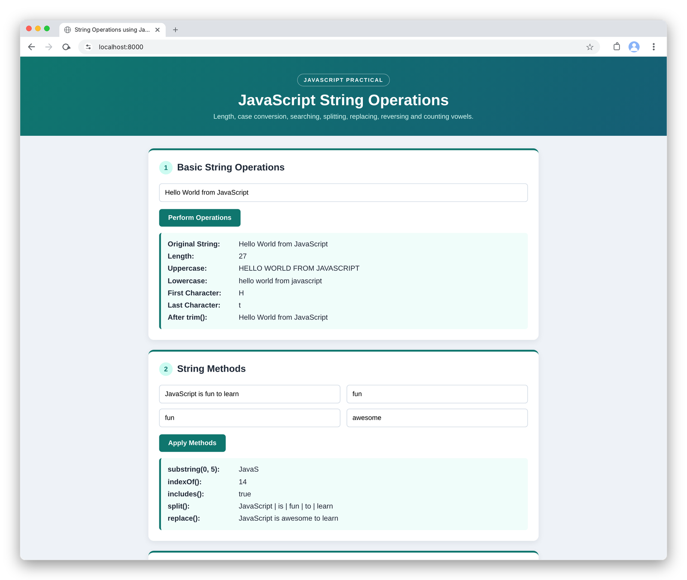
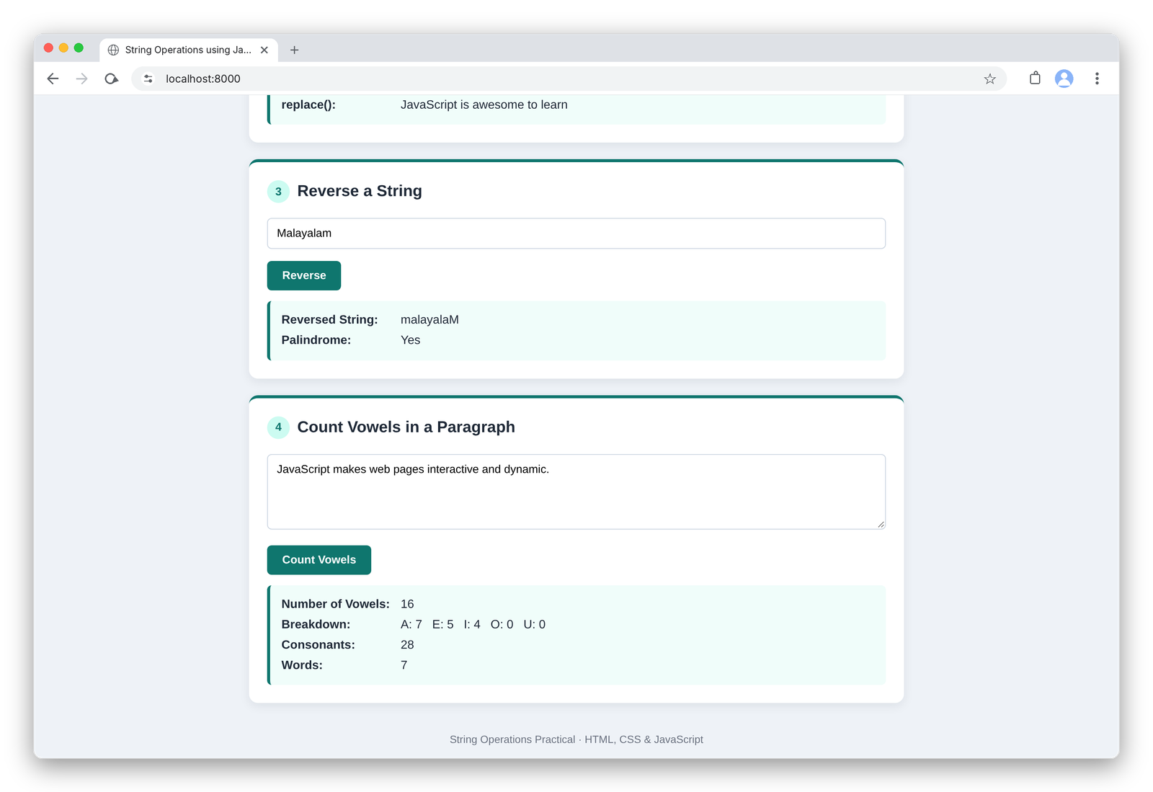

RESULT
The experiment was successfully performed and the concepts of JavaScript and basic string operations were performed.

